**Olympics History:**

**A Data Visualization Application**



**Prepared by Team Thundercats**

Shubhangi Rakhonde

David Schechter

Zayd Hammoudeh

**Date of Submission: May 22, 2015**

**Table of Contents**

1. Summary 1

2. Application Overview 1

3. Typical Users 1

4. Application Presentation 2

5. Application Components 2

5.1. Website Template 2

5.2. Tableau 3

5.2.1. Multiple Visualization Types 4

5.2.2. Data Spotlighting 4

5.2.3. Data Tips 5

5.2.4. Multi-Y Graphs 6

5.2.5. Sortable Table 7

5.3. GitHub – The Application Runtime Platform 8

6. Data Sources 8

7. Webpage Text 10

8. Data Visualizations 11

8.1. Total Summer Olympic Medals Won 11

8.2. Effect of Geopolitics on Olympic Medal Wins – Charting the Rise and Fall of Superpowers 11

8.3. Dollars for Medals – Relation between a Nation’s GDP and the Number of Medals Won at the London 2012 Olympics 13

8.4. Quantifying the Most and Least Athletic Countries – Country Population per Medal at the London 2012 Olympic Games 13

8.5. Growth in the Number of Olympic Events 14

8.6. United States Medal Wins – A Home Advantage 14

8.7. Summer Olympic Games Host Cities 14

8.8. Athletes Attending the 2012 London Olympics by Country 14

8.9. If Michael Phelps were a Country 15

List of Webpage Text References 17

**List of Figures**

Figure 1 – Persistent Navigation with Embedded Images for Recognition 3

Figure 2 – Olympics History Application Logo 3

Figure 3 – Breadcrumbs in the Applications “United States” Page 3

Figure 4 – Olympics Geopolitics Graph Displayed Normally 5

Figure 5 – Olympics Geopolitics Graph Displayed with Data Spotlighting 5

Figure 6 – Data Tip for the Displaying the Total Number of Medals Won by Poland and How Many were Bronze 6

Figure 7 – Multi-Y Graph Comparing Population per Medal versus Total Medals Won 6

Figure 8 – Multi-Y Graph Sorted by Either the Left or Right Axes 7

Figure 9 – Line Graph Showing the Effect of Geopolitics on Summer Olympic Medal Count 11

Figure 9 – Line Graph Showing the Effect of Geopolitics on Summer Olympic Medal Count 12

Figure 9 – Graph 13

Figure 9 – Symbol Map of the Summer Olympic Games Host Cities 14

Figure 9 – Stacked Bar Graph Comparing Michael Phelps Medal Total to Various Countries 15

# Summary

On May 12, 2014, Team Thundercats presented our final project for CS235. Our web application uses varying data visualization techniques to provide insight into the history of the summer Olympics. This document provides an overview of the application including its expected users, architectural components, and provides a detailed description of the conclusions that can be drawn from each of its data visualizations.

# Application Overview

Every two years, the world gathers to celebrate amateur sports at the Olympic Games. While over 219 million Americans watched the London 2012 summer Olympics and cheered as the United States won more medals than any other nation, most viewers failed to understand the varied dynamics associated with the US’ perceived Olympic dominance.

When ranking a nation’s performance at the Olympic Games, most think solely about the total number of medals won. However, this formula is overly simplistic. Our application provides tools to more broadly understand the factors that contribute to a nation’s performance at the Olympics. The following is a list of the key dynamics we wanted users to more completely understand when considering a nation’s Olympic performance:

Geopolitics

National Economic Power/Output

Population Size

Host City

Number of Participating Athletes

Event Bias

These guiding concepts/goals served as the core of our thought process when selecting our data visualizations.

It is important to note that while this report and our application discusses the Olympics generally, we chose to focus solely on the summer Olympics for clarity of data presentation.

# Typical Users

The potential user base for our Olympics history application is very broad. It is intended to cover anyone who is interested in learning more about the summer Olympics. However, we did focus more on an American audience in many of our visualizations. While some in the class may not originally come from this country, the United States has one of the most extensive Olympic histories, making it a prime subject for study and analysis.

# Application Presentation

All semester, our team has avoided slide-focused presentations as they can cause the audience to quickly lose interest and/or become distracted. It was our position that a very short presentation followed by a longer demonstration would be more engaging and informative to the audience. Given the very positive feedback we received from both Professor Mak and the class regarding our previous presentations, we saw no need to change our approach for the final project.

Despite being the first team to present and the only ones who presented early, we felt our presentation was very successful. Our application has a clear story, and the dynamic data visualizations lend themselves well to a more interactive presentation.

We have submitted our presentation slides with this submission. The file name is: “CS235 - Team Thundercats - Final Project Presentation.pptx”.

# Application Components

Our application has three primary components, which are described in the following sections. In addition, we included with our submission our source code which is in the zip file named “CS235 – Final Project – Source Code.zip”.

As a note to any users of our application, we fully populated the navigation menus to give the site an increased feeling of realism. However, only of a subset of the links take the user to actual pages. For a list of the application’s working pages, kindly see the section entitled “Data Visualizations” where each subsection corresponds to a page on our site.

## Website Template

Our application adapted an existing HTML5 and CSS template[1]. We selected this template because it had a professional appearance and because it made effective use of multiple web design patterns including:

**Visual Framework** – Across all pages, our application has a common framework that allows users to access all of the application’s features. This allows us to provide a persistent and consistent navigation platform which in turn enables users to build a strong, working base of knowledge on how to access various site features.

What is more, an advanced feature of this template’s navigation structure is that it includes embedded images as part of the navigation bar (shown inside blue rectangles in figure 1). This allows users to use recognition when identifying the menu item that aligns with their goals and not solely recall.



Figure – Persistent Navigation with Embedded Images for Recognition

**Carousel** – On the front page, there is a carousel of iconic Olympic images. Most users (in particular those who already have some knowledge about the Olympics) will recognize that many of these images came from multiple Olympics games, as far back as 1936. This recognition will assist users in cultivate for users the mental modal that this site is focused on Olympic history.

**Escape Hatch** – In the upper left corner of each page is our application’s “Olympics History” logo (see figure 2). By clicking on the logo, the user is returned to our application’s home page. This approach allows users to feel free to explore each page with reduced fear of not being able to return.



Figure – Olympics History Application Logo

**Breadcrumbs** – With the exception of the home page, all pages on the site have breadcrumbs that allow users to know the current page they are on and to return to parent pages in the navigation tree.



Figure – Breadcrumbs in the Application’s “United States” Page

## Tableau

Since this project is, at its core, focused on data visualization, the software used to visualize that data is critical. The reasons we chose Tableau as the data visualization tool for our application were:

**Full Student Version** – As part of its “academic program”, Tableau offers the full version of the software free to students. For more information on this, please see here:

<https://www.tableau.com/academic/students>

**Large User Base** – A user must spend a non-insignificant amount of time experimenting with Tableau before s/he is able to efficiently create good visualizations. For our team, it generally took at least 8 hours before we reached that threshold. If Tableau did not have as large of a user base as it does, it would have taken us much longer because we would not have had the opportunity to reference all the user generated tutorials and YouTube videos that helped us learn the tool’s fine details.

**Advanced Feature Set** – Different features within Tableau allow users to include multiple data visualization design patterns into their applications. The follow subsections enumerate different data visualization design patterns we used in our application. Note that this is not a complete list. Rather, we focused on those aspects we found could be described effectively in a text document.

### Multiple Visualization Types

The heart of any data visualization are the different types of visualizations it can create. The following is a list of the types of visualizations we used in our application; below each type are the names of visualizations that used that visualization model.

**Normal Bar Chart**

Dollars for Medals – Relation between a Nation’s GDP and the Number of Medals Won at the London 2012 Olympics

Quantifying the Most and Least Athletic Countries – Country Population per Medal at the London 2012 Olympic Games

**Stacked Bar Chart**

United States Medal Wins – A Home Advantage

If Michael Phelps were a Country

**Line Graph**

Effect of Geopolitics on Olympic Medal Wins – Charting the Rise and Fall of Superpowers

Growth in the Number of Olympic Events

**Filled Map**

Total Summer Olympic Medals Won

**Symbol Map**

Summer Olympic Games Host Cities

Athletes Attending the 2012 London Olympics by Country

Note that preceding list of visualization types is only a subset of those supported by Tableau.

### Data Spotlighting

Data spotlighting allows users to select to emphasize a particular portion of the data without losing its context with respect to the rest of the data. Figures 4 and 5 show the same graph displayed normally and with data spotlighting respectively. Note that in Figure 5, the red line becomes prominent as the rest of the data is dimmed.

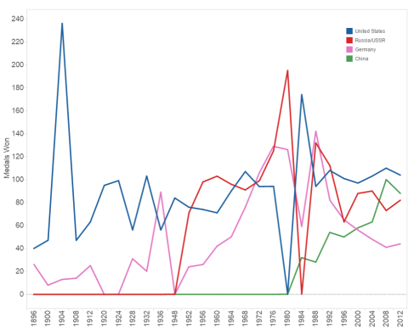

Figure – Olympics Geopolitics Graph Displayed Normally

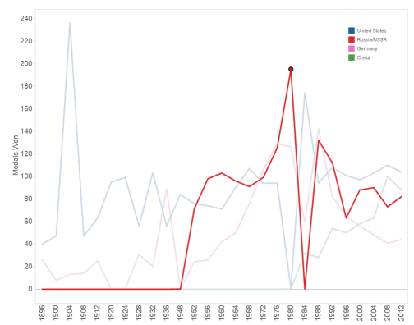

Figure – Olympics Geopolitics Graph Displayed with Data Spotlighting

Data spotlighting is enabled in all of our application’s data visualizations.

### Data Tips

In displays where there is a significant amount of data, getting the exact value of a particular entity may be difficult. Data tips allow users to get more information about a specific portion of the data by hovering over it. Figure 6 shows a data tip (surrounded by a green rectangle) in our data visualization “If Michael Phelps were a Country”. Note that it displays the country name along with the number of bronze medals and the total number of medals Poland won; this tool tip makes information readily available to a user which would otherwise be more onerous to determine.

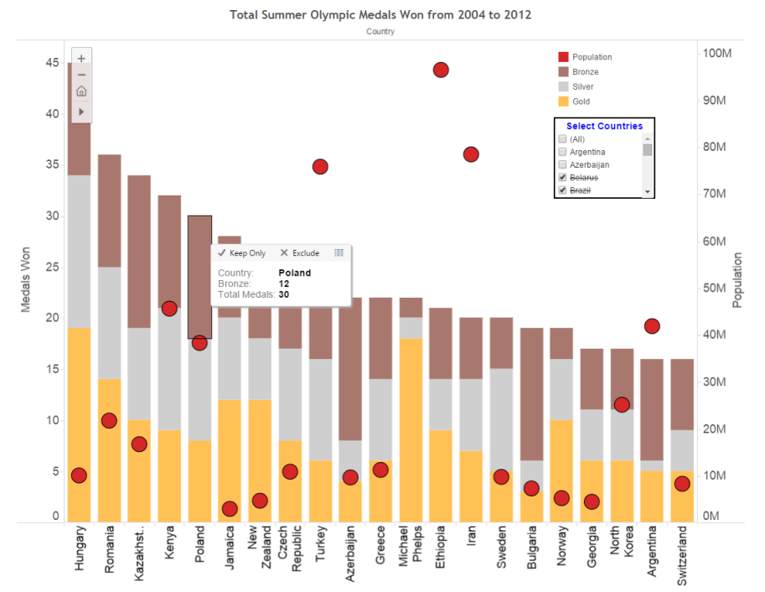

Figure – Data Tip for the Displaying the Total Number of Medals Won by Poland and How Many were Bronze

Data tips are enabled in all of our application’s data visualizations.

### Multi-Y Graphs

When trying to identify a relationship between two distinct but related data variables, it is often not possible to use the same scale/axis to display them both. In such cases, using multiple Y-axes is the best solution. Figure 7 has two Y-axes; on the left Y-axis, the population per Olympic medal is displayed while on the right Y-axis is the number of medals won. Note that the common X-axis is a set of countries.

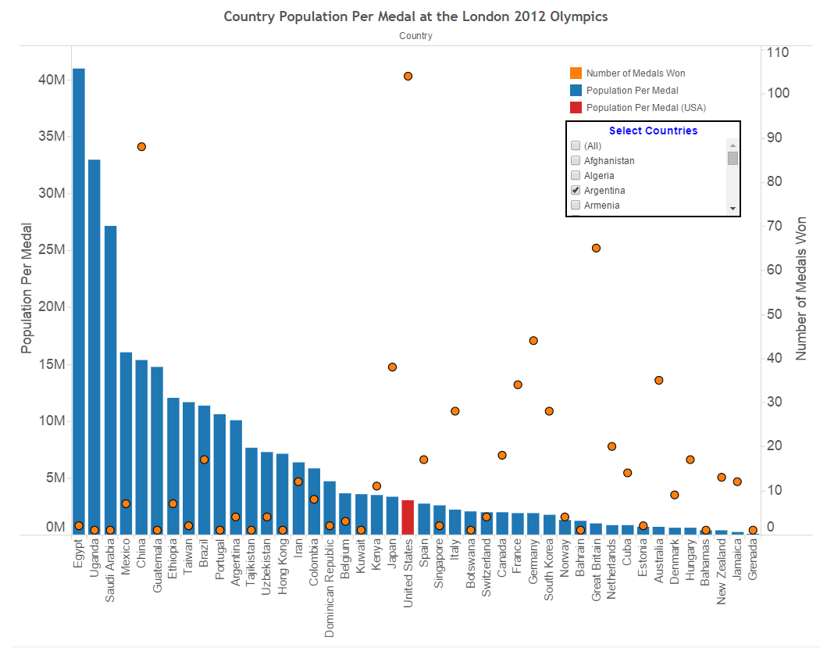

Figure – Multi-Y Graph Comparing Population per Medal versus Total Medals Won

Our application used multi-Y graphs in the following data visualizations:

### Sortable Table

The Sortable Table design pattern is something of a misnomer as while it specifically mentions tables by name, the pattern applies to much more than that. As shown in the in-class lecture material, it can also apply to bar graphs as well.

In our application, the default was to always sort data according to the left Y-axis. However, if the user wanted to sort according to the right Y-axis, s/he does so by hovering the mouse over axis title and selecting sort ascending or descending.

Figure 8 shows the same graph sorted by the left Y-axis (see left graph) and by the right Y-axis (see right graph).

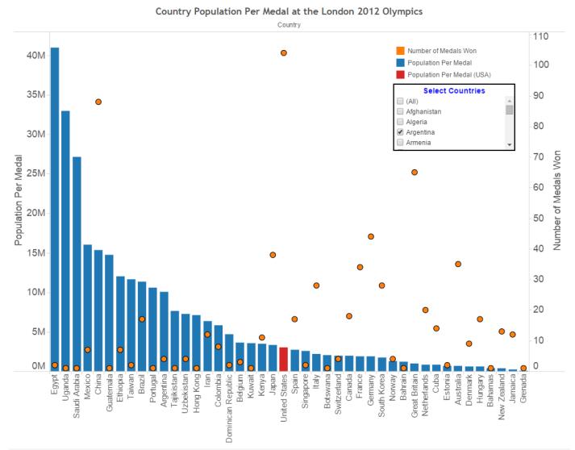 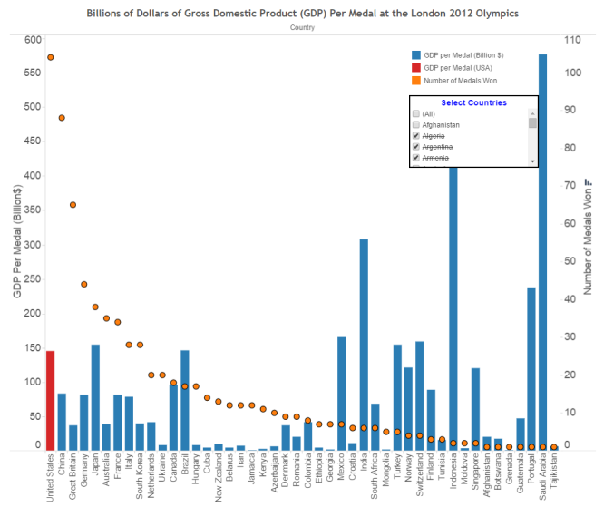

Figure – Multi-Y Graph Sorted by Either the Left or Right Y-Axis

Our application supports sortable tables on the data visualizations with multiple Y-graphs namely:

## GitHub – The Application Runtime Platform

Throughout the semester, Team Thundercats used GitHub as our revision control repository. One of GitHub’s lesser known features is that built into every GitHub repository is a free web server. To run our application, we recommend that you access our GitHub page directly. A link to the application’s home page is below.

<http://rawgit.com/ZaydH/CS235/master/Final_Project/index.html>

As a service to future students, we will keep our project live in perpetuity as part of our group’s GitHub repository. It is our humble recommendation that for subsequent classes, it be a requirement that the students publish their projects to a course GitHub repository so future students may view them easily for inspiration, ideas, and to better understand the professor’s expectations.

# Data Sources

Multiple different data sources were used to generate the different data visualizations included with our applications. Below is a list of the data sources we used; included with each is a reference to the data visualization where the data set was used:

1. **Olympic Medal Wins by Games**
   1. **Description:** This dataset lists the number of gold, silver, and bronze medals won by the United States at each summer Olympic Games.
   2. **Data Source:** <http://chandoo.org/wp/2008/08/06/olympic-medal-country-year-excel-bubble-chart/>
   3. **Data Visualization:**
2. **United States’ Olympic Medals Won by Games**
   1. **Description:** This dataset lists the number of gold, silver, and bronze medals won by the United States at each summer Olympic Games.
   2. **Data Source:** <http://www.olympic.org/united-states-of-america>
   3. **Data Visualizations:**
3. **China’s Olympic Medals Won by Games**
   1. **Description:** This dataset lists the number of gold, silver, and bronze medals won by the People’s Republic of China at each summer Olympic Games.
   2. **Data Source:** <http://www.olympic.org/people-s-republic-of-china>
   3. **Data Visualization:**
4. **Soviet Union’s Olympic Medals Won by Games**
   1. **Description:** This dataset lists the number of gold, silver, and bronze medals won by the Soviet Union at each summer Olympic Games.
   2. **Data Source:** <http://www.pbs.org/redfiles/sports/stry/medals.htm>
   3. **Data Visualizations:**
5. **The Russian Federation’s Olympic Medals Won by Games**
   1. **Description:** This dataset lists the number of gold, silver, and bronze medals won by the Russian Federation at each summer Olympic Games.
   2. **Data Source:** <http://www.olympic.org/russian-federation>
   3. **Data Visualizations:**
6. **Germany’s Olympic Medals Won by Games**
   1. **Description:** This dataset lists the number of gold, silver, and bronze medals won by Germany at each summer Olympic Games.
   2. **Data Source:** <http://www.olympic.org/germany>
   3. **Data Visualizations:**
7. **Total Medals by GDP**
   1. **Description:** This dataset quantifies the relationship between a nation’s economic output (measured as GDP – Gross Domestic Product) and the number of medals it won at the 2012 London Olympics.
   2. **Data Source:** <http://www.medalspercapita.com/#medals-by-gdp:2012>
   3. **Data Visualizations:**
8. **Total Medals Won Per Capita**
   1. **Description:** This dataset quantifies the relationship between a nation’s population and the number of medals it won at the 2012 London Olympics.
   2. **Data Source:** <http://www.medalspercapita.com/#medals-per-capita:2012>
   3. **Data Visualizations:**
9. **Olympic Events by Games**
   1. **Description:** This dataset provides a table enumerating the events each summer Olympics. Note that we excluded the 1906 Intercalated Games since that is no longer considered an official Olympic Games by the International Olympic Committee (IOC).
   2. **Data Source:** <http://en.wikipedia.org/wiki/Olympic_sports>
   3. **Data Visualization:**
10. **Summer Olympic Games Host Cities**
    1. **Description:** This dataset provides a list of host cities for each of the summer Olympic games.
    2. **Data Source:** <http://www.olympic.org/olympic-games>
    3. **Data Visualization:**
11. **Athletes Attending the London 2012 Olympics by Country**
    1. **Description:** This dataset provides a list of host cities for each of the summer Olympic games.
    2. **Data Source:** <http://en.wikipedia.org/wiki/2012_Summer_Olympics>
    3. **Data Visualization:**
12. **All Time Olympic Medal Totals by Country**
    1. **Description:** This dataset provides a table listing the number of summer Olympics medals won by each country.
    2. **Data Source:** <http://www.olympic.it/english/medal/id_summer.htm>
    3. **Data Visualization:**
13. **Olympic Medals Won by Michael Phelps**
    1. **Description:** This dataset provides a list of the Olympic medals won by athlete Michael Phelps at each of the summer Olympics at which he competed.
    2. **Data Source:** <http://www.olympic.org/michael-phelps>
    3. **Data Visualization:**

# Webpage Text

Since this project is intended to be a user interface design course’s culminating experience, we did not consider that it would be necessary (much less important) to write original text for each of the application’s pages. Rather, the vast majority of the text on our application’s pages is merely a tool to lend realism and context to the application. As such, other than the headlines for each of the pages and the graph titles, none of the text in our application is original. It was all sourced from different web pages we found.

The section entitled “List of Webpage Text References” includes a list of pages from which we borrowed text content. Any pages missing from this list are an oversight on our part since we fully acknowledge that all of the text content (excluding the previously mentioned exceptions) is not original.

# Data Visualizations

The following subsections enumerate the nine data visualizations included in our application. Each subsection also describes our goals when creating the visualization and how the visualization addresses our goals.

## Total Summer Olympic Medals Won

**Web Page Address:** <http://rawgit.com/ZaydH/CS235/master/Final_Project/country_profiles.html>

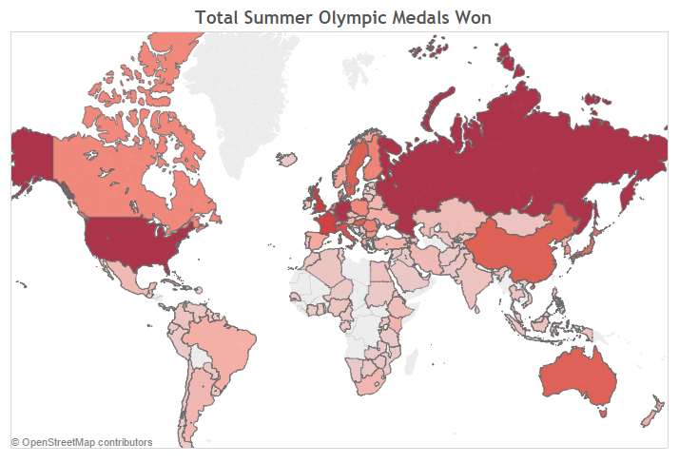

Figure – Filled Map Showing the Total Number of Summer Olympic Medals Won by Country

When determining the country that has performed the best at the Olympics, most think only of total medal count; some may have considered our application would be incomplete without this clichéd visualization. However, we deliberately kept the visualization as simple as possible because while it does clearly show that the nations that have won the most Olympic medals are the United States, Germany, and Russia, we know it does not tell the whole story; instead this visualization will serve as a point of contrast to show the user that Olympics performance is much more complex than just who won the most medals.

## Effect of Geopolitics on Olympic Medal Wins – Charting the Rise and Fall of Superpowers

**Web Page Address:** <http://rawgit.com/ZaydH/CS235/master/Final_Project/geopolitics.html>

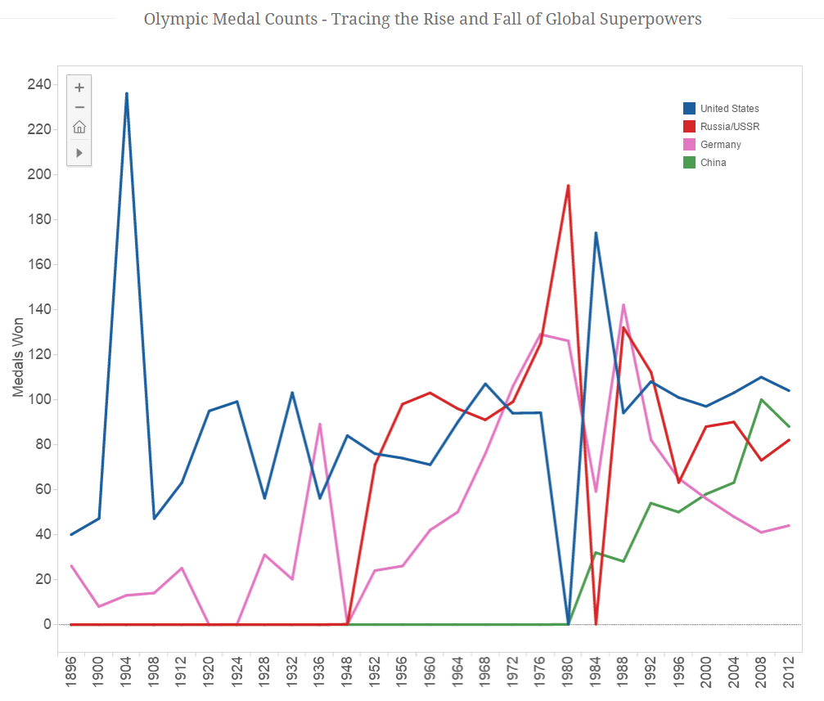

Figure – Line Graph Showing the Effect of Geopolitics on Summer Olympic Medal Count

Chapter 5 of the Olympics Charter states, “No kind of demonstration or political, religious or racial propaganda is permitted in the Olympic areas.” While this may technically be true, it somewhat belies the reality that the entire Olympic movement is often dominated by political propaganda. To illustrate this point, we have graphed the summer Olympic Medal totals at each summer Olympic Games for each of the 20th Century’s dominant superpowers. The following list describes how each nation’s medal count is deeply reflective of the on-going geopolitical situation.

**Germany** – Leading up to World War II, Nazi Germany was intent on showing the superiority of the Aryan race and at the behest of the Nazi propaganda minister Joseph Goebbels, Nazi Germany pushed its athletes to perform well at the 1936 Berlin games. Due to this pressure, Germany won more medals in those games than any other nation.

It must be noted that Germany is the only country to have lost two world wars. Its defeats are clearly shown in our data visualization as Germany won no medals in 1920, 1924, and 1948.

Once Germany had begun to rebuild after World War II, East Germany wanted to show its superiority over West Germany and began an extensive doping program. This led to a surge of Olympic medal wins until the Berlin Wall fell in 1989 after which there was a precipitous drop in the number of medals won by the united Germany.

**Soviet Union/Russia:** Before 1950, the Soviet Union was very domestic centric in its politics, and only looked outside its borders regarding matters of national security (e.g. Molotov-von Ribbentrop Pact, World War II related diplomacy, etc.). This inward focus is reflected in the fact the Soviet Union never competed in a summer Olympics before 1952.

By 1952, the Cold War had already become hot in places like the Korean Peninsula. What is more, communist and democratic nations were pitted against each other to show the superiority of their political systems. Similar to Nazi Germany in the 1930’s, the Soviet Union invested heavily in athletes, which is reflected in the number of summer Olympic medals it won. The only exception to this is when it boycotted the 1984 Olympics for the geopolitical reason that the games were held in Los Angeles.

**China:** Before 1980 when President Richard Nixon visited mainland China, the nation was politically isolated. The infrastructure had been largely destroyed by Japan in World War II and by civil war. This national isolation is reflected in that China won no Olympics medals before 1984. However, China as a nation is on the rise both economically and at the Olympic Games. It has steadily won an increasing number of medals, and just like it does economically, China now only trails the United States in medals won at the summer Olympics.

**United States:** The 20th Century was America’s century. It won two World Wars and is the only one of the four major superpowers on this graph to not have had any political revolutions. Rather, the United States has been the hallmark of stability. This political stability is reflected in US’ comparatively stable medal win count. The only two outliers are the 1904 games, when the Olympics were still in their infancy, and in 1980-1984, when the games were dominated by Cold War politics, which led to alternating boycotts.

## Dollars for Medals – Relation between a Nation’s GDP and the Number of Medals Won at the London 2012 Olympics

**Web Page Address:** <http://rawgit.com/ZaydH/CS235/master/Final_Project/economics.html>

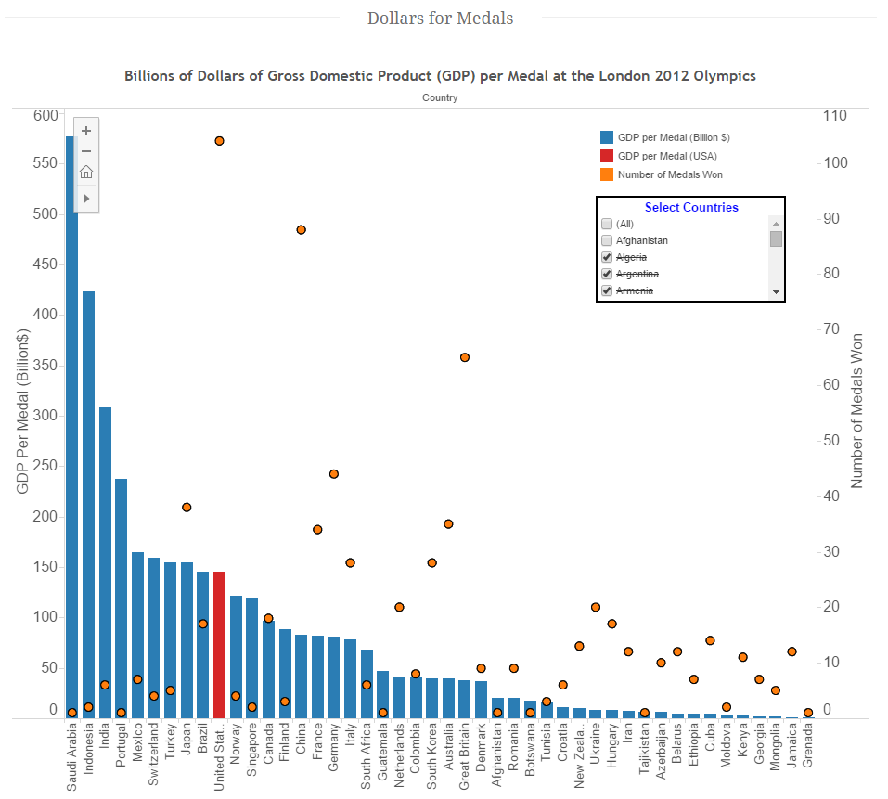

Figure – Multi Y-Axis Bar Graph Contrasting GDP to Medal Ratio and the Total Number of Medals Won

Competing in the Olympics can be expensive. While some sports like marathon have very low cost barriers to entry, others like swimming and equestrian events require specialized equipment that may be unavailable to many people. Hence, even if an individual has the greatest potential to achieve greatness, that greatness may be squandered if they cannot afford to utilize that potential. This data visualization quantifies the relationship between a nation’s economic output and the medals won at the London 2012 games.

To quantify how well a nation translates its economic output to Olympic medals, we calculated the GDP to Medal ratio via the simple formula:

Note we only considered the number of medals won at the London 2012 games (i.e. the most recent).

As shown in figure 11, the country that had the best GDP to medal ratio was Grenada at $800M per medal; however, it only won a single medal. As such, it should be considered an outlier (this type of outlier necessitated we also include in the visualization the number of medals won). Rather, we would argue Jamaica’s $1.3B per medal is a much greater accomplishment as it won 12 medals. In contrast, Saudi Arabia had $576B of GDP for the single medal it won.

While this visualization works well for countries with low to moderately sized GDPs, it can be overly harsh in punishing countries with very large GDPs. For example, if the United States had won every medal at London 2012, its GDP to medal ratio would have only been $15.7B well behind nations like Tunisia, Ethiopia, Kenya, Georgia, and Mongolia, much less Jamaica.

## Quantifying the Most and Least Athletic Countries – Country Population per Medal at the London 2012 Olympic Games

**Web Page Address:** <http://rawgit.com/ZaydH/CS235/master/Final_Project/population.html>

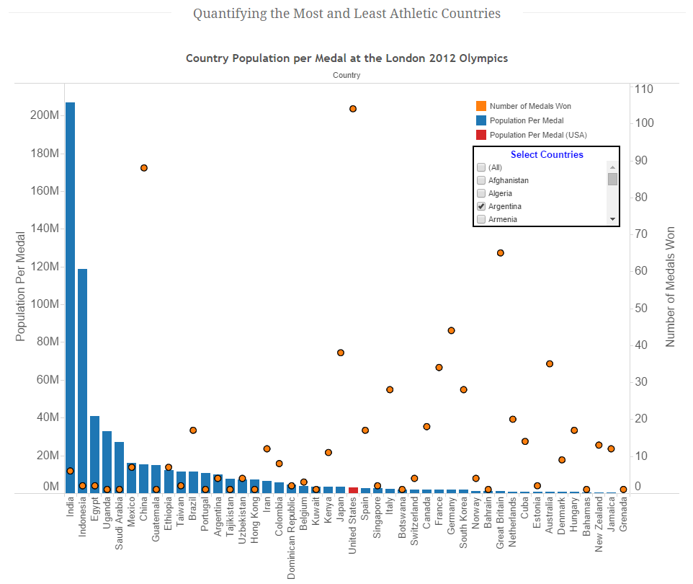

Figure – Multi Y-Axis Bar Graph Contrasting Population to Medal Ratio and the Total Number of Medals Won

Concerning the lottery, it is often said that the more tickets one buys, the better the chances of winning. Some argue that this applies to a “genetic lottery” for Olympic athletes. For example, most people could never have been as fast as Usain Bolt or as athletic as LeBron James even if they did everything they possibly could.

As shown in figure 11, India and Indonesia are exceptionally poor at cultivating Olympic medal winning athletes despite having very large populations. What is more, some countries like Pakistan and the Philippines do not appear on this graph because they did not win any medals at all. In contrast, Jamaica won twice the number of medals than India at the London 2012 Olympics despite having India having more than 450 times the population. Hence, this visualization shows that certain nations are far better at producing Olympic medal winning athletes than others, which shows the “more chances to win” argument has fundamental flaws.

This visualization does not stray far from the theme that no one statistic can completely quantify a nation’s Olympic performance. At the Olympic Games, the number of athletes a nation can send is not proportional to population size. For example, a nation can only send 12 players to represent it in men’s basketball irrespective of a nation’s population. This cap will make countries with large populations like China and the United States appear worse despite potentially performing well at the games. When considered from this perspective, the United States performance appears far better.

## United States Medal Wins – A Home Advantage

**Web Page Address:** <http://rawgit.com/ZaydH/CS235/master/Final_Project/united_states.html>

## Summer Olympic Games Host Cities

**Web Page Address:** <http://rawgit.com/ZaydH/CS235/master/Final_Project/previous_games.html>

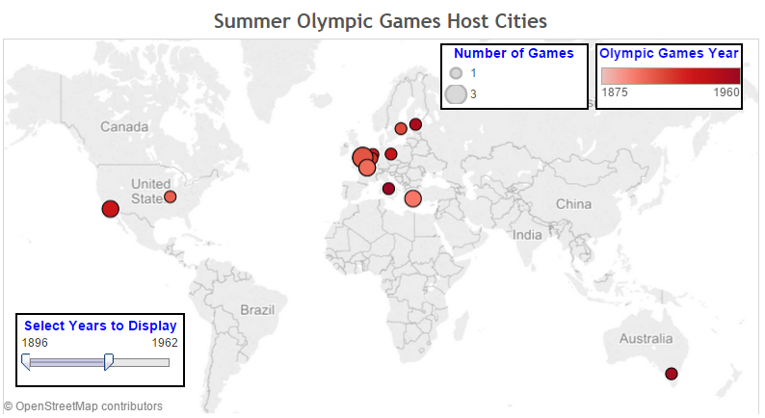

Figure – Symbol Map of the Summer Olympic Games Host Cities

When most fans of the Olympics think about their city or nation hosting the Olympics, they think primarily in terms of national prestige or glory; politicians may think of the economic benefits. However, few think of how the benefit to the medal totals.

Section #8.5 clearly showed that the medal totals for the United States tended to go up when the Olympics were hosted in the United States or in a neighboring country. What is more, in section #8.2, China won its most medals when the Olympics were held in Beijing. There is no reason to believe this phenomenon does not apply to other countries as well. In contrast, obvious factors, including the cost to travel and supporting fans, would lead one to believe this effect applies global.

Before 1964, all Olympics had been held in developed Western countries with only three being held outside of Europe. This would naturally skew Olympic medal totals toward these countries. As the Olympics have become more of a truly global events, it has been or will be held in more non-traditional cities including Moscow, Tokyo (twice), Rio de Janeiro, Beijing, Mexico City, and Seoul. This increased global participation may lead to a more balanced total medal table in the future.

## Athletes Attending the 2012 London Olympics by Country

**Web Page Address:** <http://rawgit.com/ZaydH/CS235/master/Final_Project/previous_games.html>

## Growth in the Number of Olympic Events

**Web Page Address:** <http://rawgit.com/ZaydH/CS235/master/Final_Project/events.html>

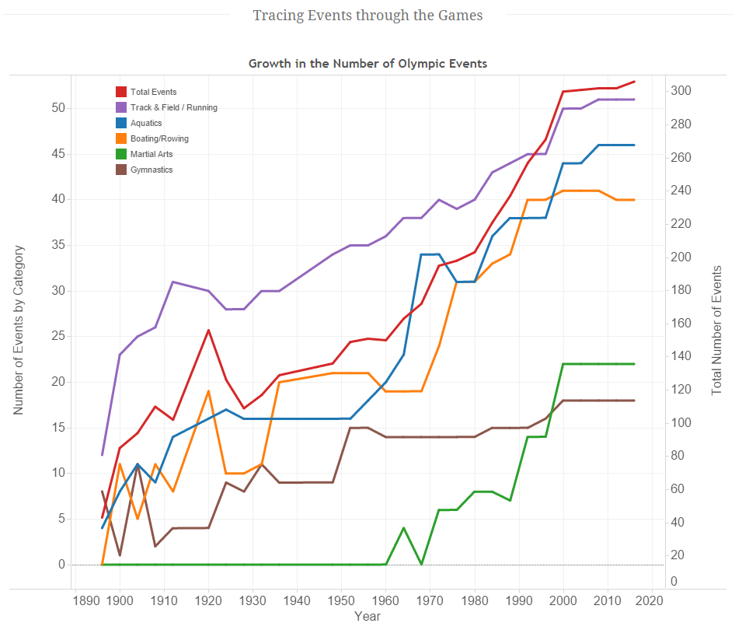

Figure – Line Graph Showing the Growth in the Number of Events at the Summer Olympics

It is only possible to win an Olympic medal in events that actually exist. This may seem like an obvious statement, but it is not one that can be overlooked. The types of events included in the Olympics were originally set primarily by Americans and Europeans. As shown in Figure 13, while the number of events at the Olympics has grown substantially since the first Olympics in 1986, they have growth has largely been in the same original core group (with the exception of martial arts).

Some argue that the types of events at the Olympics benefit specific countries over others. An example of this is cricket, which has only ever appeared at a single Olympic games (1900) despite being one of the most popular games on the planet. The International Olympic Committee (IOC) decides which events to include and exclude from each games. In recent years, there has been a shift towards a more global centric event line-up by removing games such as softball and baseball and replacing them with more international games like rugby.

If past trends are an indication, it is unlikely that the Olympics will adopt a significant number of new events that are more traditionally eastern focused. Rather, what is more likely is that the sports played in different countries will drift towards those that are already popular internationally. Until a more global uniformity of sports popularity is reached, the types of events at the Olympics will continue to disenfranchise certain nations.

## If Michael Phelps were a Country

**Web Page Address:** <http://rawgit.com/ZaydH/CS235/master/Final_Project/michaelphelps.html>

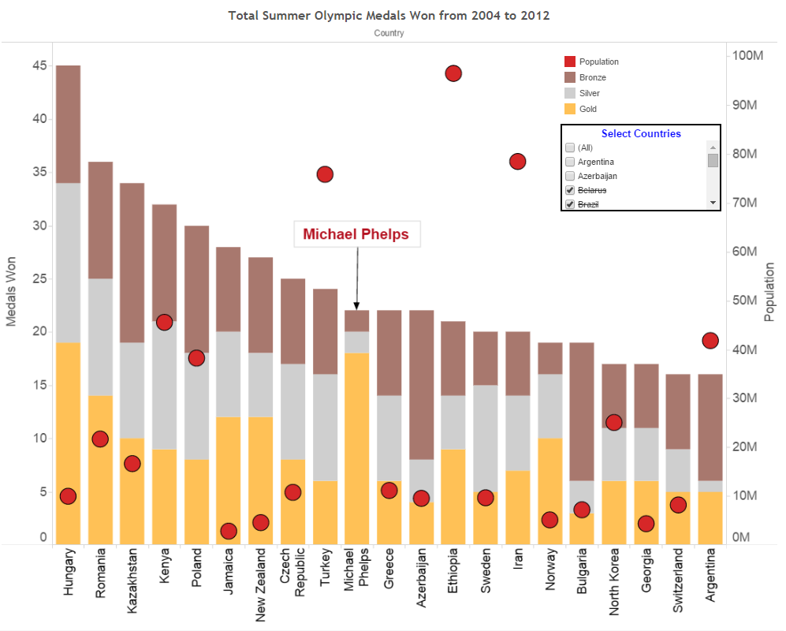

Figure – Stacked Bar Graph Comparing Michael Phelps Medal Total to Various Countries

The previous visualizations were intended to show some of the nuances associated with describing Olympic performance. In contrast, the final visualization in figure 13 is intended as a tool to show the dominating Olympic performance of a single individual: Michael Phelps. It does this by bringing together three distinct pieces of data, namely:

Total Number of Medals Won by Country

Country Population Size

Medal Breakdown between Gold, Silver, and Bronze

With the exception of population size, this data applies to only the three Olympic Games at which Michael Phelps competed (specifically the years 2004, 2008, and 2012).

This visualization shows that no country with comparable medal counts had nearly the ratio of gold medals to total medals that Michael Phelps had. What is more, despite having millions or even tens of millions of people, these countries had similar medal totals to Phelps. As an example, the combined medal output of over 95 million Ethiopians could not match Michael Phelps by himself. This visualization succinctly, and perhaps a bit entertainingly, shows Phelps’ superior and dominant Olympic performance in the last three games.

# List of Webpage Text References

|  |  |
| --- | --- |
| [ ] | ‘Olympic sports’, *Wikipedia*, (wiki article). Available at: <<http://en.wikipedia.org/wiki/Olympic_sports>>. [Accessed 10 May 2015]. |
| [ ] | ‘United States at the Olympics’, *Wikipedia*, (wiki article). Available at: <http://en.wikipedia.org/wiki/United_States_at_the_Olympics>. [Accessed 10 May 2015]. |
| [ ] | ‘Michael Phelps’, *Wikipedia*, (wiki article). Available at: <http://en.wikipedia.org/wiki/Michael_Phelps>. [Accessed 10 May 2015]. |
| [ ] | ‘All-time Olympic Games Medal Table’, *Wikipedia*, (wiki article). Available at: <http://en.wikipedia.org/wiki/All-time_Olympic_Games_medal_table>. [Accessed 10 May 2015]. |
| [ ] | ‘2012 Summer Olympics’, *Wikipedia*, (wiki article). Available at: <http://en.wikipedia.org/wiki/2012_Summer_Olympics >. [Accessed 10 May 2015]. |
| [ ] | ‘All-time Olympic Games Medal Table’, *Wikipedia*, (wiki article). Available at: <http://en.wikipedia.org/wiki/All-time_Olympic_Games_medal_table>. [Accessed 10 May 2015]. |
| [ ] | Boston.com, (2015). *Winning golds without gold: an economic analysis of the medal standings*. [online] Available at: http://www.boston.com/sports/blogs/statsdriven/2012/07/winning_golds_without_gold_an.html [Accessed 10 May 2015]. |
| [ ] | Iwallerstein.com, (2015). *The Olympics and Geopolitics*. [online] Available at: http://iwallerstein.com/the-olympics-and-geopolitics/ [Accessed 10 May 2015]. |
| [ ] | Berg, C. (2015). Politics, not sport, is the purpose of the Olympic Games. *IPA Review*, [online] pp.15-18. Available at: https://www.ipa.org.au/library/publication/1213771802_document_60-3_berg.pdf [Accessed 10 May 2015]. |
| [ ] | Yahoo Eurosport UK, (2015). *The Olympic medal ‘per capita’ table*. [online] Available at: https://uk.eurosport.yahoo.com/blogs/london-spy/olympic-medal-per-capita-table-125300447.html [Accessed 10 May 2015]. |
| [ ] | Team USA, (2015). *USOC - General Information | United States Olympic Committee*. [online] Available at: http://www.teamusa.org/About-the-USOC/Inside-the-USOC/History [Accessed 10 May 2015]. |

1. For a link to the template, please see: <http://themeforest.net/item/alexx-multipurpose-html5-theme/3370259>